System Capacity and Care Load Analytics for Unaccompanied Children: A Data-Driven Framework for Monitoring Healthcare System Sustainability

Author
Nibhisha S Kakrania

Abstract
The Unaccompanied Alien Children (UAC) Program administered by the U.S. Department of Health and Human Services (HHS) represents a complex humanitarian and healthcare delivery system responsible for the protection, sheltering, medical assessment, and reunification of children entering the United States without a parent or legal guardian. Effective operation of this system requires continuous monitoring of care capacity, resource utilization, and population flow dynamics.
This research develops a healthcare capacity analytics framework using operational data from January 2023 through December 2025. By integrating custody populations, transfer activity, discharge processes, and active care loads, the framework provides actionable indicators for measuring operational sustainability. Key metrics include Total System Load, Net Daily Intake, Backlog Accumulation, Discharge Offset Ratio, and Capacity Stress Indicators.
Analysis identified substantial fluctuations in system demand, with a peak care load of 11,762 children and an average system load of 6,232 children. Results demonstrate the importance of sponsor placement efficiency in reducing backlog pressure and maintaining sustainable care operations. The proposed framework supports evidence-based decision-making and provides a scalable model for healthcare capacity monitoring within humanitarian response systems.
Keywords: Healthcare Analytics, Capacity Planning, Humanitarian Operations, Child Welfare, Public Health Analytics, Time-Series Analysis, Decision Support Systems

1. Introduction
The Unaccompanied Alien Children (UAC) Program serves as a critical component of the United States humanitarian response framework. Children apprehended by U.S. Customs and Border Protection (CBP) are transferred into the custody of the Department of Health and Human Services (HHS), where they receive healthcare, shelter, educational services, and welfare support until reunification with approved sponsors.
As migration patterns fluctuate, federal agencies face significant challenges in maintaining sufficient care capacity while ensuring high-quality service delivery. Periods of increased arrivals may lead to overcrowding, higher healthcare demand, staffing pressures, and resource allocation challenges.
Traditional reporting mechanisms primarily provide operational counts but often fail to deliver strategic insights regarding capacity utilization, system sustainability, and future resource requirements. This study addresses this limitation by developing a comprehensive analytics framework for monitoring and evaluating care system performance.

2. Literature Review
Healthcare operations research consistently emphasizes the importance of capacity planning, demand forecasting, and resource optimization. Similar principles are applicable within humanitarian care systems where service demand can fluctuate rapidly.
Studies in healthcare management demonstrate that real-time monitoring systems improve operational responsiveness and reduce the risk of resource shortages. Humanitarian logistics research further highlights the role of predictive analytics in improving emergency preparedness and response efficiency.
Despite extensive literature on hospital capacity management and public health operations, limited research has examined integrated analytical frameworks specifically designed for child welfare care systems. This study contributes to the field by adapting healthcare capacity management principles to the operational realities of the UAC program.

3. Research Objectives

Primary Objectives
- Quantify daily and cumulative care system load.
- Evaluate balance between intake and discharge activities.
- Identify periods of capacity stress and relief.
- Monitor backlog accumulation patterns.
- Assess long-term operational sustainability.

Secondary Objectives
- Support workforce planning.
- Improve shelter allocation decisions.
- Enhance situational awareness.
- Enable data-driven policy evaluation.

4. Dataset Description
The dataset contains daily operational observations from January 2023 through December 2025.
Variable | Description
Date | Reporting date
Children Apprehended | Daily intake volume
Children in CBP Custody | Active CBP population
Children Transferred | Daily movement into HHS care
Children in HHS Care | Active HHS population
Children Discharged | Sponsor placements

5. Methodology
The study employs a quantitative time-series analytics approach.

Data Preparation
- Date normalization
- Missing date identification
- Duplicate detection
- Chronological ordering
- Logical consistency validation

Derived Metrics
Total System Load
Total System Load = CBP Custody + HHS Care
Net Daily Intake
Net Daily Intake = Transfers − Discharges
Backlog Indicator
Cumulative Net Daily Intake
Discharge Offset Ratio
Discharges ÷ Transfers
Capacity Stress Threshold
90th percentile of Total System Load

6. Results and Discussion

6.1 Overall System Capacity
The study analyzed 720 reported operational days covering 1,075 calendar days.
Key findings include:
KPI | Value
Average Total System Load | 6,232
Peak System Load | 11,762
Peak Load Date | Dec 20, 2023
Average CBP Population | 169
Average HHS Population | 6,063
Capacity Stress Days | 108
Capacity Relief Days | 702

Figure 1. Total System Load Trend (2023–2025)
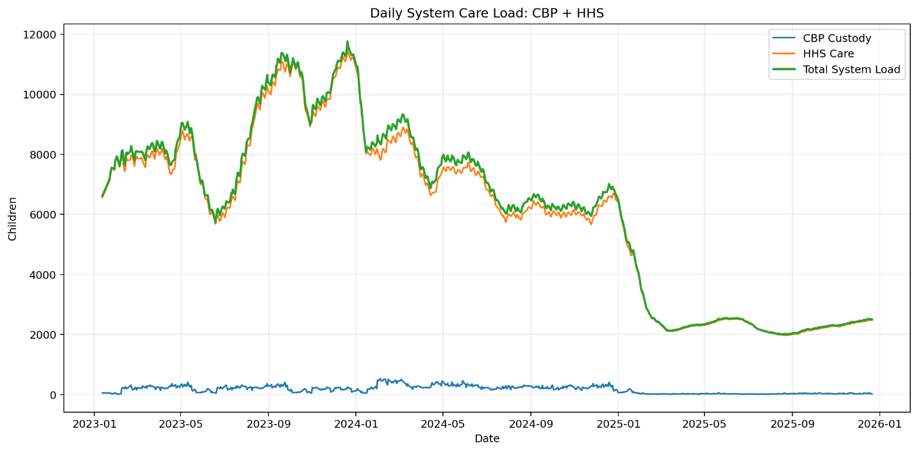The system load trend demonstrates substantial variation throughout the observation period. The highest observed load occurred during late 2023, indicating a period of elevated operational responsibility. Following this peak, system load gradually declined, suggesting successful implementation of discharge and reunification processes.

6.2 Intake and Discharge Performance
Across the study period:
Metric | Total
Children Apprehended | 67,337
Children Transferred | 92,641
Children Discharged | 124,853
The average Discharge Offset Ratio exceeded 2.0, indicating that discharge activity generally outpaced incoming transfers.

Figure 2. Net Intake Pressure
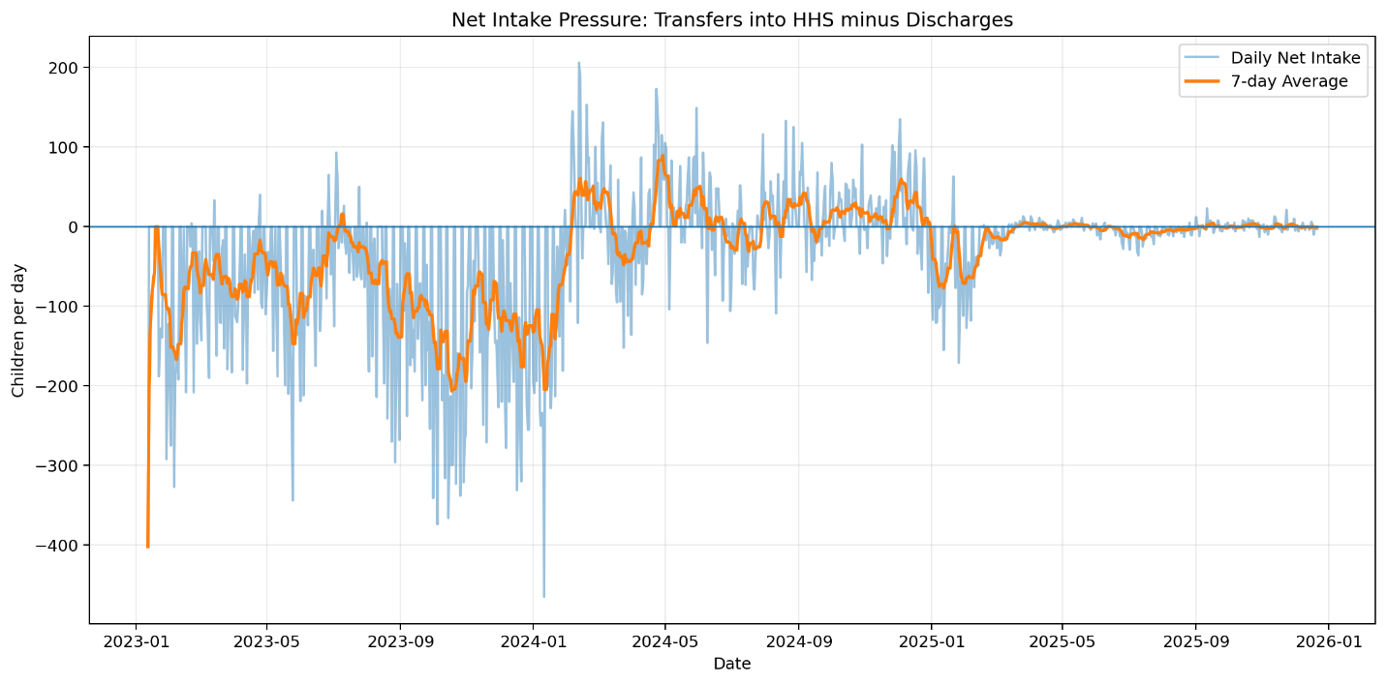Net Intake Pressure illustrates the balance between incoming transfers and outgoing discharges. Positive values indicate growing pressure, while negative values indicate relief. The overall negative cumulative pressure demonstrates the system’s ability to reduce care populations over time.

6.3 Backlog Analysis
Backlog accumulation serves as an important indicator of operational strain.

Figure 3. Backlog Indicator
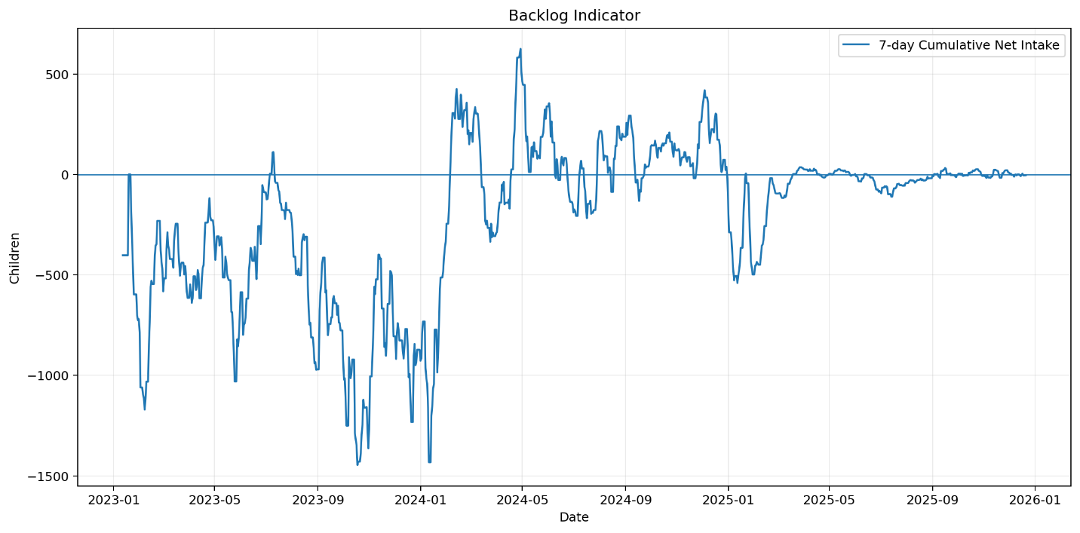Backlog growth remained temporary throughout the study period. While short-term increases occurred during surge periods, discharge activity consistently reduced accumulated pressure, preventing sustained overcrowding.

6.4 Capacity Stress Assessment
The 90th percentile stress threshold was used to identify periods of elevated system burden.

Figure 4. Rolling Capacity Stress Analysis
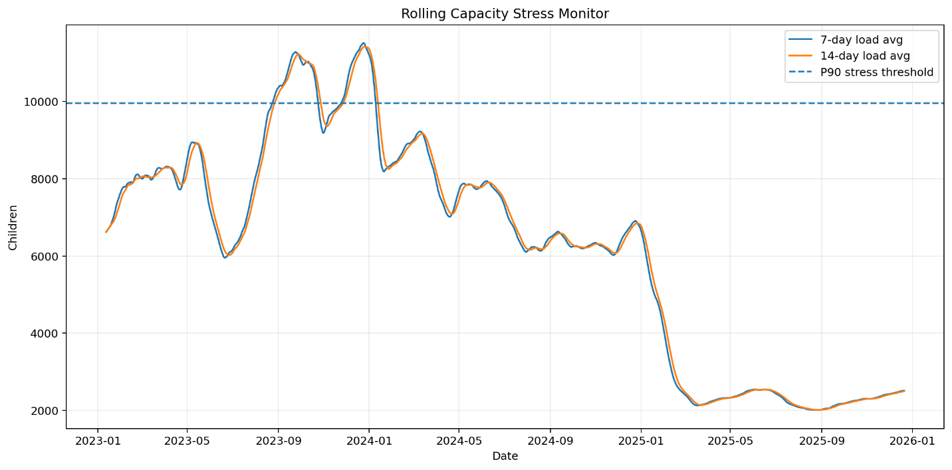Rolling-average analysis reveals several periods where care demand approached or exceeded stress thresholds. These intervals likely required increased staffing levels, expanded shelter utilization, and enhanced healthcare resource allocation.

6.5 Monthly Operational Flow Balance
Monthly aggregation provides insight into long-term operational stability.

Figure 5. Monthly Flow Balance
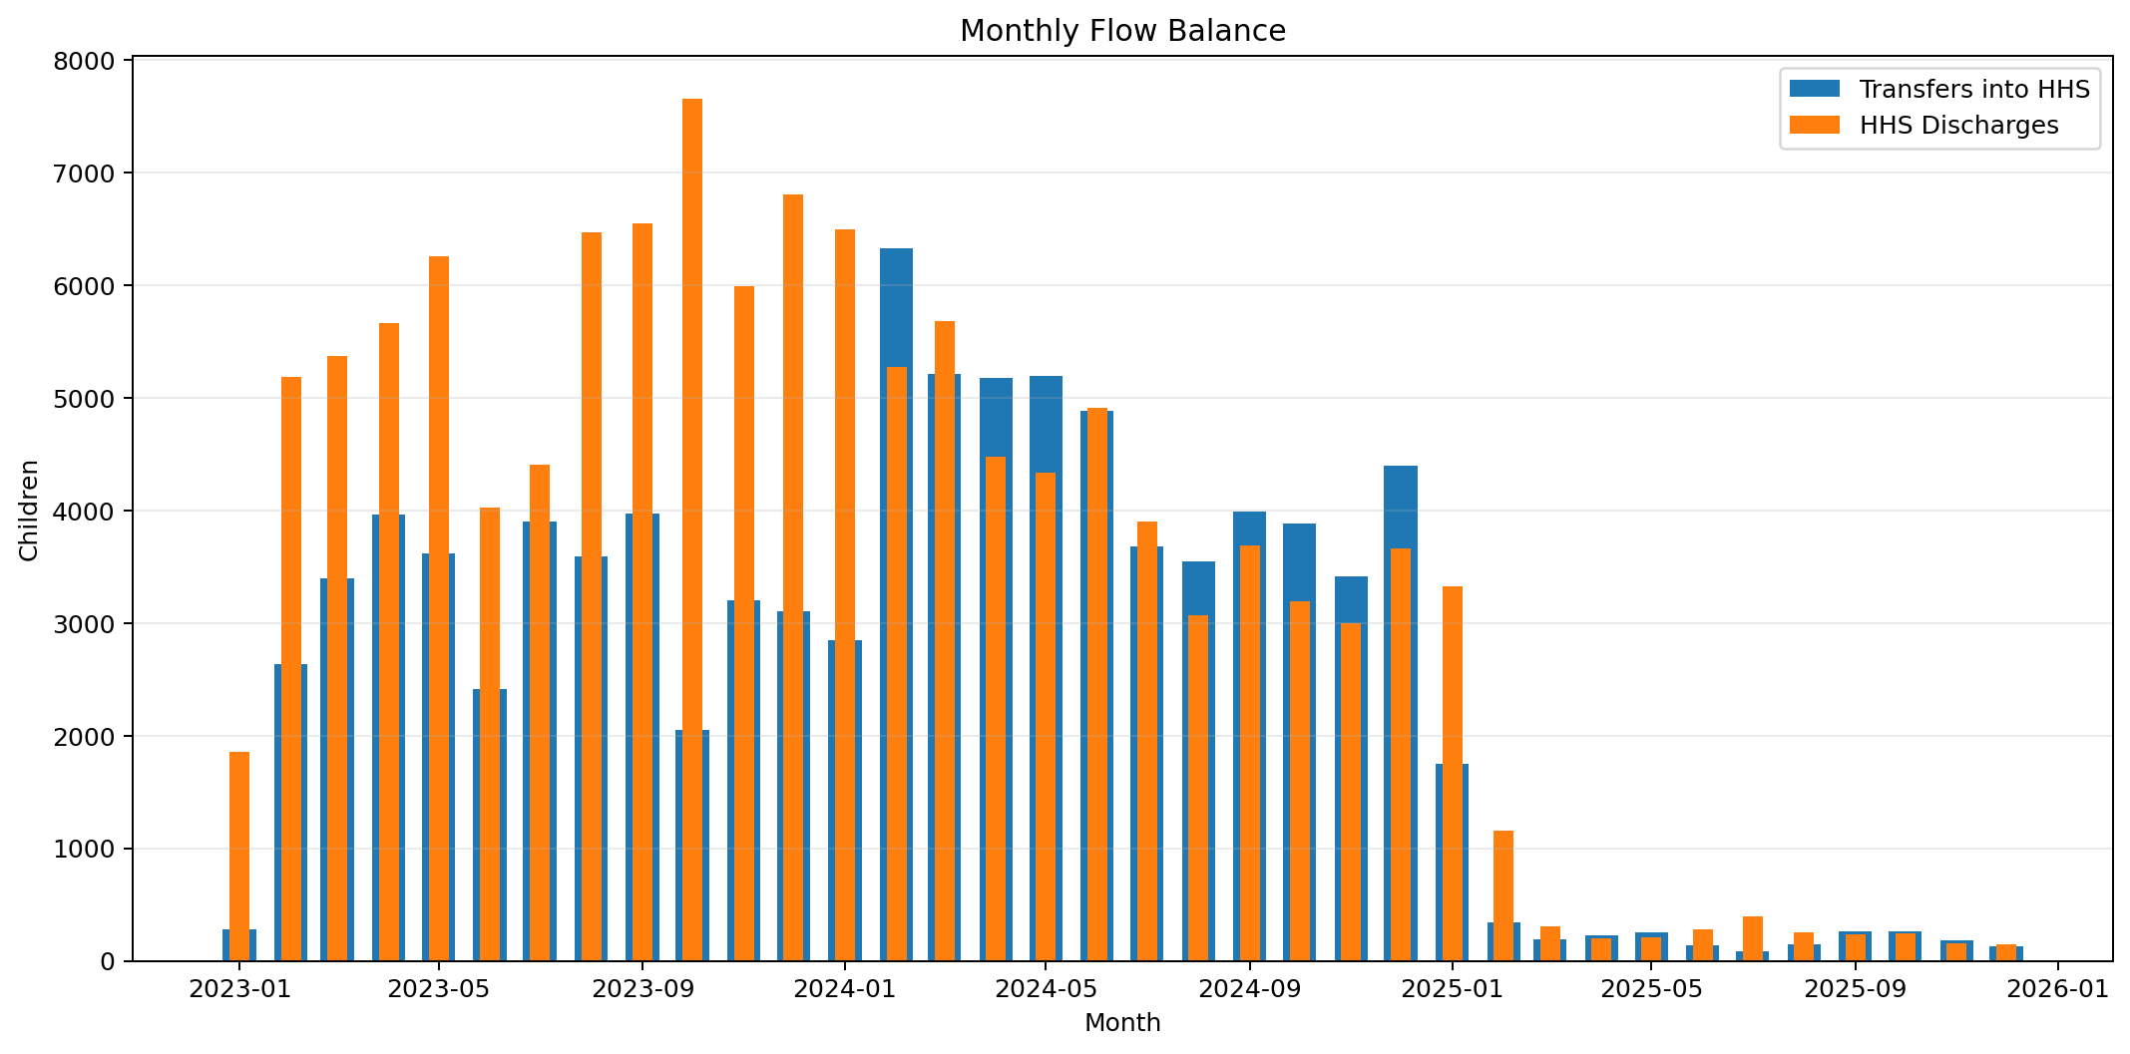Monthly flow analysis demonstrates recurring cycles of increased intake followed by stabilization. These patterns suggest that the care system possesses adaptive capacity capable of responding effectively to fluctuating demand conditions.

6.6 Volatility Assessment
Volatility measures system stability over time.

Figure 6. Care Load Volatility Index
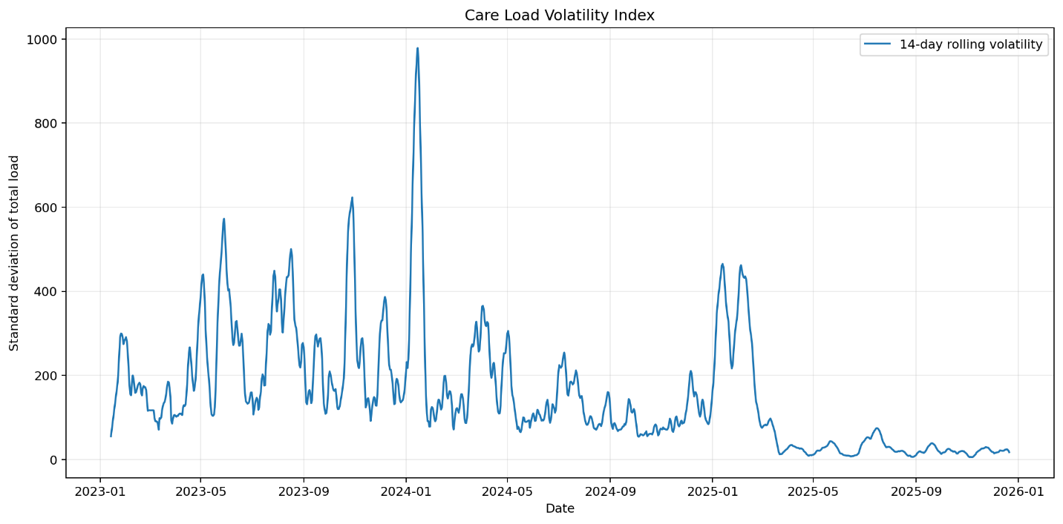
Although periods of rapid change occurred, volatility remained within manageable levels throughout most of the study period. This finding suggests that federal agencies successfully adjusted operational resources in response to changing demand.

7. Policy Implications
Several important policy implications emerge from the analysis:
- HHS facilities represent the primary contributor to total care burden and should remain the central focus of capacity planning efforts.
- Sponsor reunification efficiency plays a critical role in reducing operational pressure.
- Integrated monitoring systems provide substantially greater insight than isolated custody counts.
- Predictive analytics can improve preparedness and reduce the risk of overcrowding.

8. Recommendations
- Deploy real-time capacity monitoring dashboards.
- Establish automated stress-threshold alert systems.
- Expand surge staffing capabilities.
- Improve sponsor placement processing efficiency.
- Integrate forecasting models into planning activities.
- Standardize reporting metrics across agencies.

9. Limitations
This analysis is based on aggregated operational data and does not include facility-level occupancy rates, demographic characteristics, healthcare utilization metrics, or geographic variation. Future studies incorporating these factors may provide more detailed operational insights.

10. Future Research
Future work should investigate:
- Machine learning forecasting models
- Geographic demand forecasting
- Facility-level occupancy analysis
- Resource optimization simulations
- Healthcare utilization prediction

11. Conclusion
This research demonstrates the value of healthcare analytics in monitoring complex humanitarian care systems. By transforming operational records into actionable performance indicators, the proposed framework improves understanding of capacity utilization, system sustainability, and resource requirements.
The results indicate that the UAC care system generally maintained operational stability despite significant fluctuations in demand. Strong discharge performance and effective backlog management contributed substantially to long-term sustainability. The framework developed in this study provides a scalable foundation for future healthcare capacity monitoring and policy decision support.

Acknowledgements
The author acknowledges Unified Mentor and the U.S. Department of Health and Human Services project framework for providing the analytical problem statement that inspired this research.

References
Department of Health and Human Services. (2024). Unaccompanied children program. Administration for Children and Families.
United States Customs and Border Protection. (2024). Southwest land border encounters.
Administration for Children and Families. (2024). Office of Refugee Resettlement annual reports.
World Health Organization. (2023). Health systems resilience toolkit.
United Nations Children’s Fund. (2023). Child protection in humanitarian action.
Green, L. V. (2012). Queueing analysis in healthcare. Handbook of Healthcare System Scheduling.
Wiler, J. L., et al. (2013). Optimizing emergency department front-end operations. Annals of Emergency Medicine.

Appendix A: KPI Formulas
Total System Load = CBP Custody + HHS Care
Net Daily Intake = Transfers − Discharges
Discharge Offset Ratio = Discharges ÷ Transfers
Backlog Indicator = Cumulative Net Intake
Capacity Stress Threshold = 90th Percentile of Total System Load

Appendix B: Dashboard Screenshots
- Dashboard Home Screen
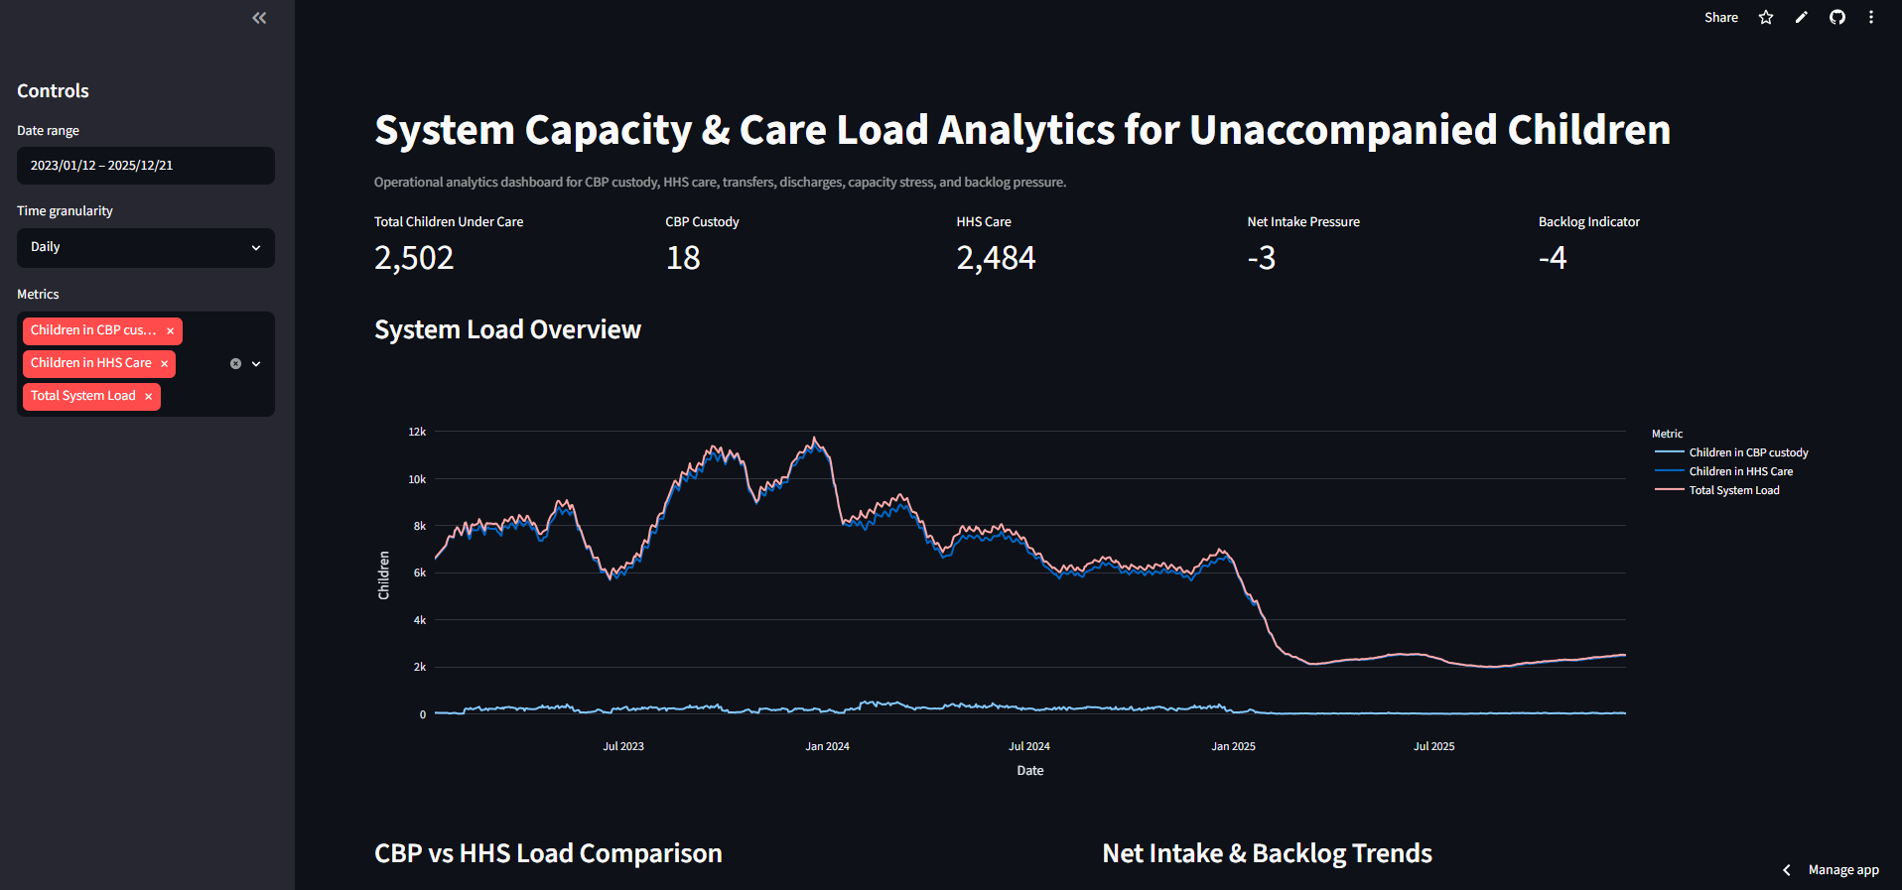

- Capacity Stress Monitor
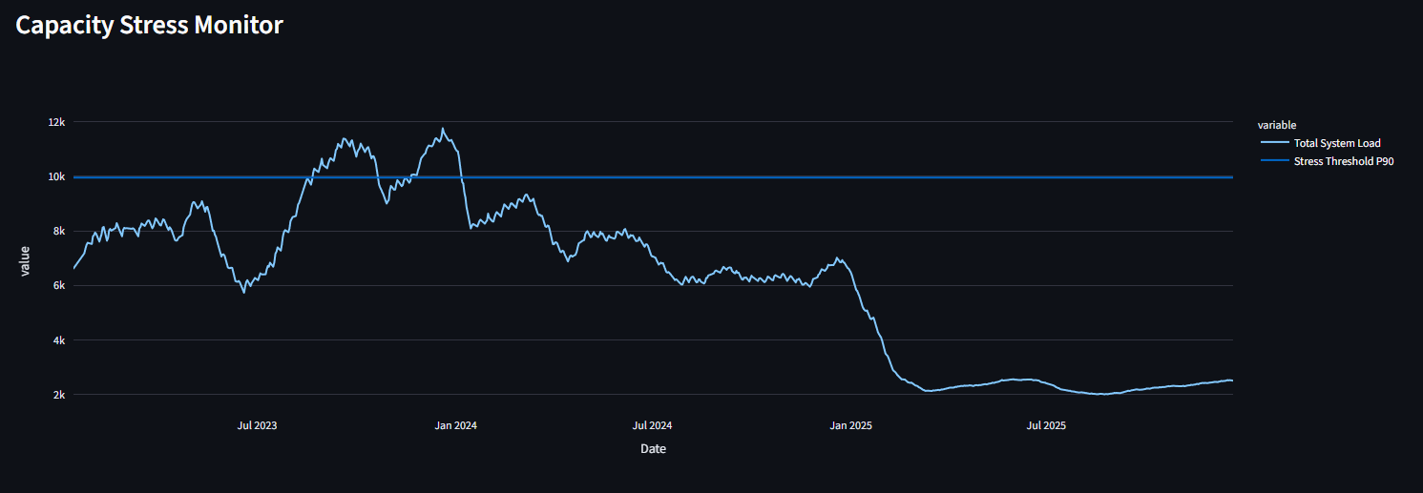
- Net Intake Analysis Panel
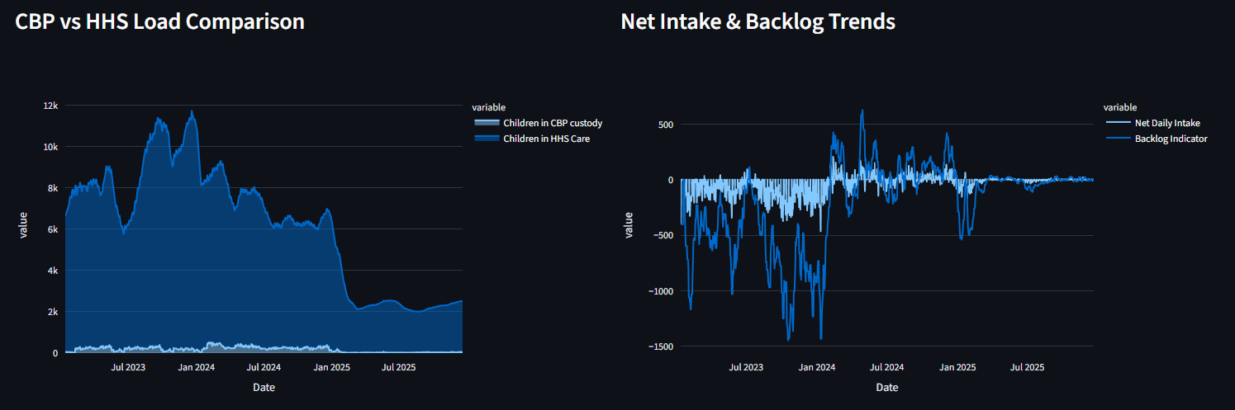

Appendix C: Summary Statistics
KPI summary table and monthly trend summary exported from the analytics workbook.
Table 1. KPI Summary of UAC Care System Performance (2023–2025)
KPI | Formula | Value | Interpretation
Total Children Apprehended | Sum of Daily Apprehensions | 67,337 | Total children entering CBP custody
Total Children Transferred to HHS | Sum of Daily Transfers | 92,641 | Children moved into HHS care facilities
Total Children Discharged | Sum of Daily Discharges | 124,853 | Successful sponsor reunifications
Average CBP Population | Mean(CBP Custody) | 169 | Average daily population in CBP custody
Average HHS Population | Mean(HHS Care) | 6,063 | Average daily population in HHS care
Average Total System Load | Mean(CBP + HHS) | 6,232 | Average children under federal responsibility
Peak System Load | Maximum System Load | 11,762 | Highest observed care burden
Peak Load Date | Date of Maximum Load | 20-Dec-2023 | Period of greatest operational demand
Net Intake Pressure | Transfers − Discharges | -32,212 | Overall discharge activity exceeded intake
Average Discharge Offset Ratio | Discharges ÷ Transfers | 2.01 | Strong ability to reduce care burden
Capacity Stress Days | Load > 90th Percentile | 108 Days | High-pressure operational periods
Capacity Relief Days | Load ≤ 90th Percentile | 702 Days | Stable operating conditions
Care Load Volatility Index | Std Dev of System Load | 2,912 | Moderate fluctuation in care demand
Backlog Accumulation Trend | Cumulative Net Intake | Declining | Indicates successful backlog reduction

Table 2. Operational Assessment Matrix
Performance Area | Status | Assessment
System Capacity | Good | Capacity generally maintained
Discharge Efficiency | Excellent | Discharges consistently exceeded transfers
Backlog Management | Good | Backlogs remained temporary
Resource Sustainability | Good | Long-term operations remained stable
Surge Preparedness | Moderate | Stress periods still occurred
Operational Resilience | Strong | System adapted to demand fluctuations

The KPI summary demonstrates that the UAC care system maintained overall operational stability throughout the study period. Although temporary periods of elevated demand were observed, discharge activity consistently exceeded incoming transfers, resulting in declining backlog pressure and sustainable care load management. The average system load of 6,232 children and peak load of 11,762 children highlight the scale of federal responsibility managed through the UAC program. Overall, the findings suggest that sponsor reunification processes played a critical role in maintaining system resilience and preventing prolonged capacity strain.

